**Regression Error Metrics**

Error Metrics are typically needed to evaluate your Ml model , with the below metrics we can evaluate how accurate the model prediction is .

1. Mean Squared Error(MSE)
2. Mean Absolute Error(MAE)
3. Root Mean Square Error(RMSE)
4. Mean Absolute Percentage Error(MAPE)

## Mean square error

The **mean square error** (MSE) is just like the MAE, but squares the difference before summing them all instead of using the absolute value.

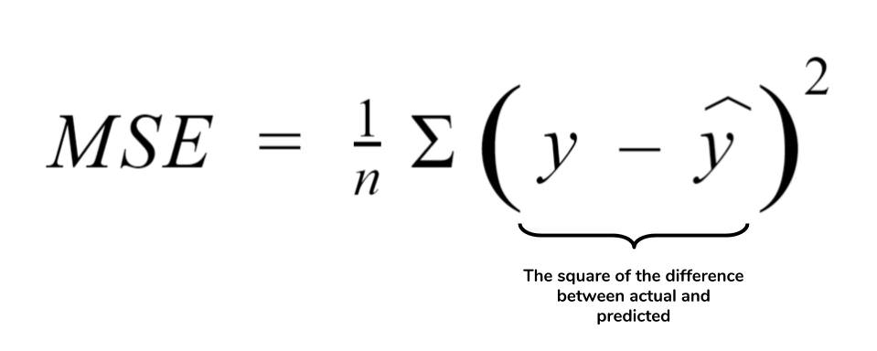

Because we are squaring the difference, the MSE will almost always be bigger than the MAE. For this reason, we cannot directly compare the MAE to the MSE. We can only compare our model’s error metrics to those of a **competing** model. The effect of the square term in the MSE equation is most apparent with the presence of outliers in our data. While each residual in MAE contributes **proportionally** to the total error, the error grows **quadratically** in MSE. This ultimately means that outliers in our data will contribute to much higher total error in the MSE than they would the MAE. Similarly, our model will be penalized more for making predictions that differ greatly from the corresponding actual value. This is to say that large differences between actual and predicted are punished more in MSE than in MAE.

**Mean absolute error**

The **mean absolute error** (MAE) is the simplest regression error metric to understand. We’ll calculate the residual for every data point, taking only the absolute value of each so that negative and positive residuals do not cancel out. We then take the average of all these residuals. Effectively, MAE describes the *typical* magnitude of the residuals.

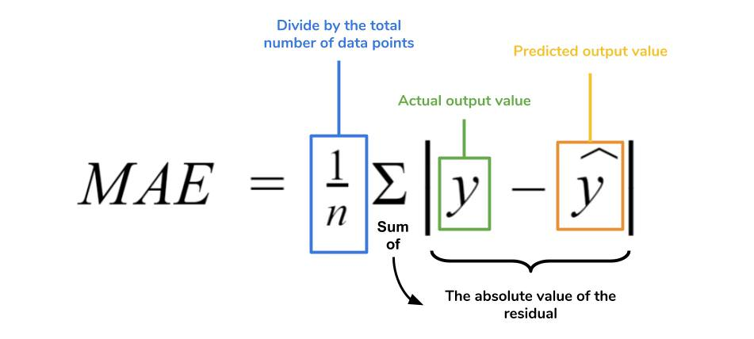

The MAE is also the most intuitive of the metrics since we’re just looking at the absolute difference between the data and the model’s predictions. Because we use the absolute value of the residual, the MAE does not indicate **underperformance** or **overperformance** of the model (whether or not the model under or overshoots actual data). Each residual contributes proportionally to the total amount of error, meaning that larger errors will contribute linearly to the overall error. Like we’ve said above, a small MAE suggests the model is great at prediction, while a large MAE suggests that your model may have trouble in certain areas. A MAE of 0 means that your model is a **perfect** predictor of the outputs (but this will almost never happen).

While the MAE is easily interpretable, using the absolute value of the residual often is not as desirable as **squaring** this difference. Depending on how you want your model to treat **outliers**, or extreme values, in your data, you may want to bring more attention to these outliers or downplay them. The issue of outliers can play a major role in which error metric you use.

**ROOT MEAN SQUARED ERROR**

**root mean squared error** (RMSE). As the name suggests, it is the square root of the MSE. Because the MSE is squared, its units do not match that of the original output. Researchers will often use RMSE to convert the error metric back into similar units, making interpretation easier. Since the MSE and RMSE both square the residual, they are similarly affected by outliers. The RMSE is analogous to the standard deviation (MSE to variance) and is a measure of how large your residuals are spread out. Both MAE and MSE can range from 0 to positive infinity, so as both of these measures get higher, it becomes harder to interpret how well your model is performing. Another way we can summarize our collection of residuals is by using percentages so that each prediction is scaled against the value it’s supposed to estimate.

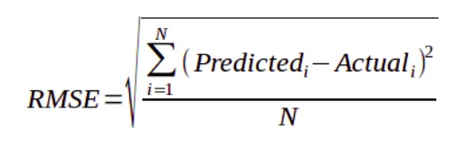

## Mean absolute percentage error

The **mean absolute percentage error** (MAPE) is the percentage equivalent of MAE. The equation looks just like that of MAE, but with adjustments to convert everything into percentages.

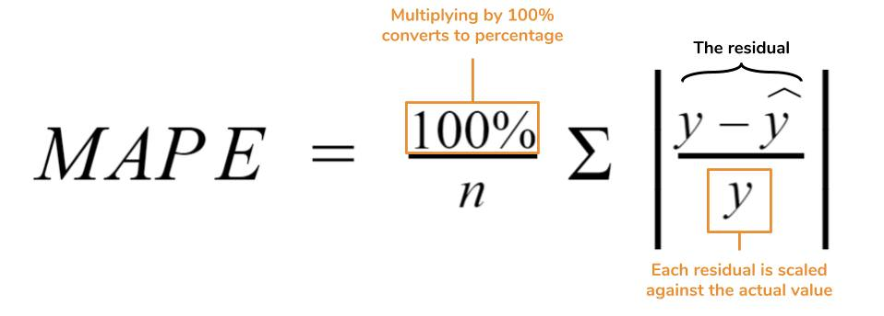

Just as MAE is the average magnitude of error produced by your model, the MAPE is how far the model’s predictions are off from their corresponding outputs on average. Like MAE, MAPE also has a clear interpretation since percentages are easier for people to conceptualize. Both MAPE and MAE are robust to the effects of outliers thanks to the use of absolute value.